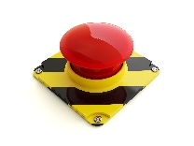
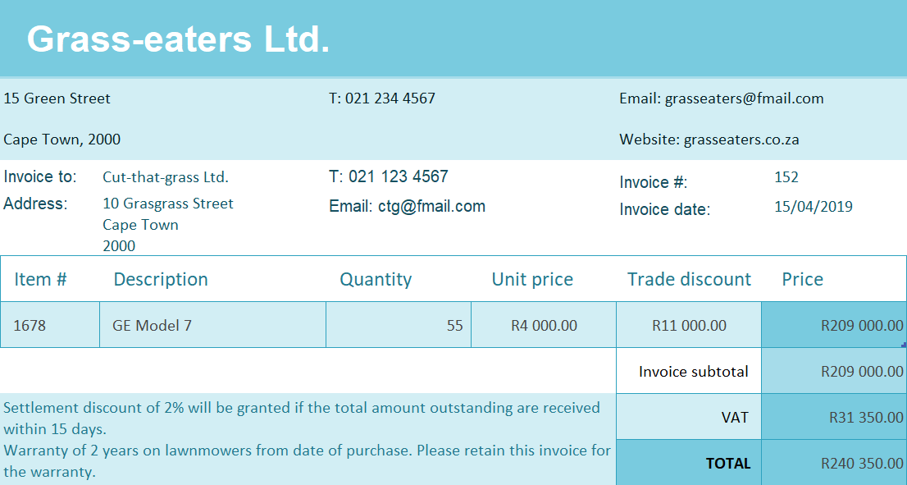
Grass-eaters Ltd is a registered VAT Vendor, which means they are legally obligated to LEVY VAT on every sale made (Output VAT)
IF Cut-that-grass Ltd. IS registered for VAT, they can CLAIM the VAT from SARS (Input VAT). 
IF Cut-that-grass Ltd. IS NOT registered for VAT, they cannot claim the Input VAT. 
Only the net amount gets paid over/ received from SARS
USE THE CORRECT TERMS:
-Levy Output VAT
-Claim Input VAT
Otherwise, no marks!

